Name : Vishal Jha

Batch : Data Engineering

Date : 23-02-2024

Topic – Azure Devops

1. Create New Organization.

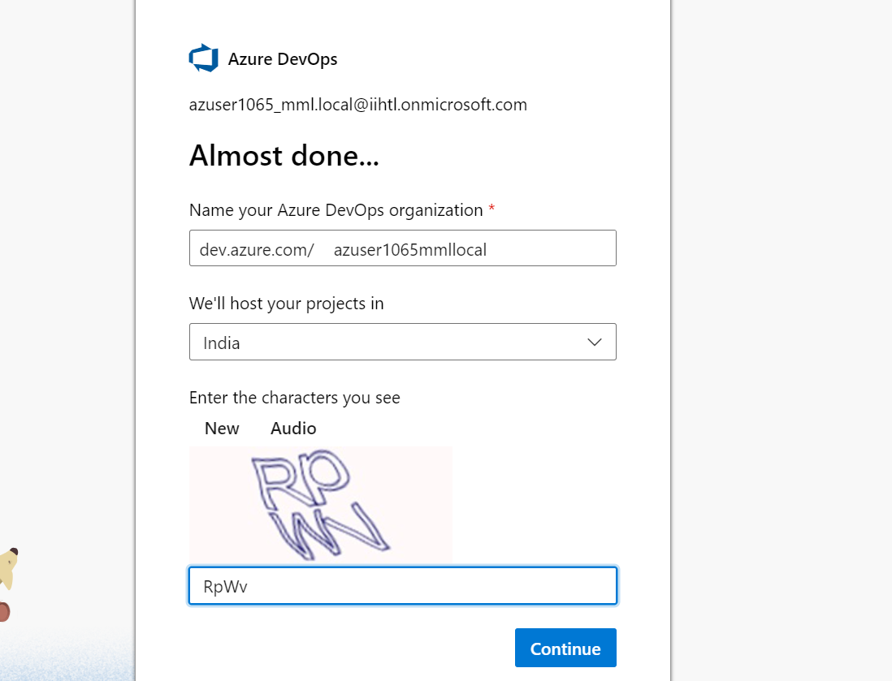

1. Create a Project.

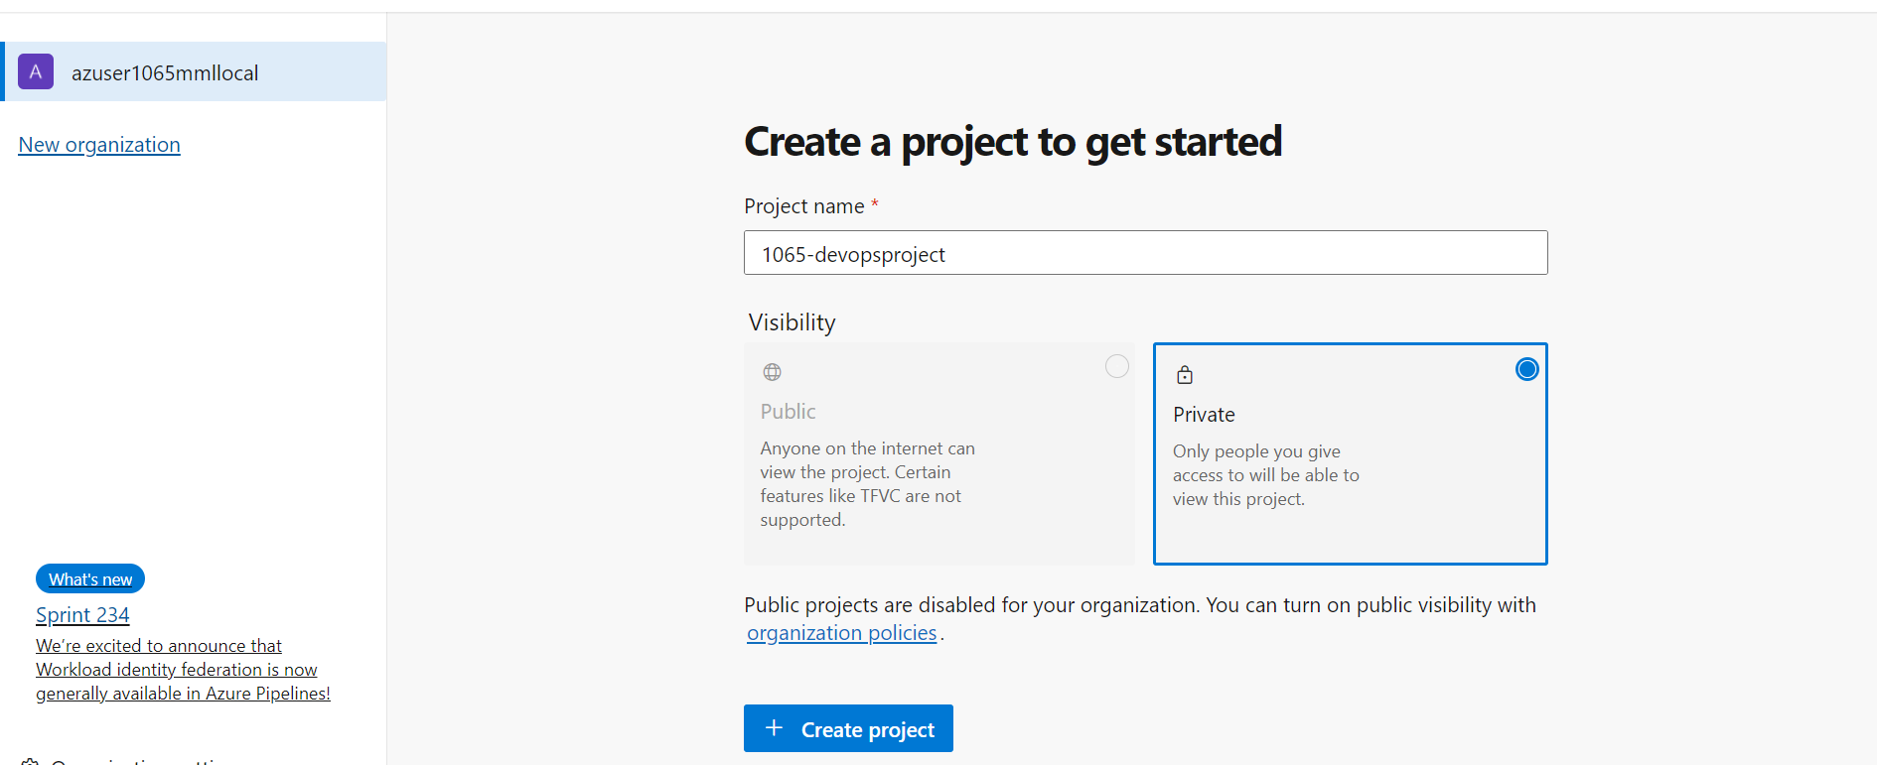

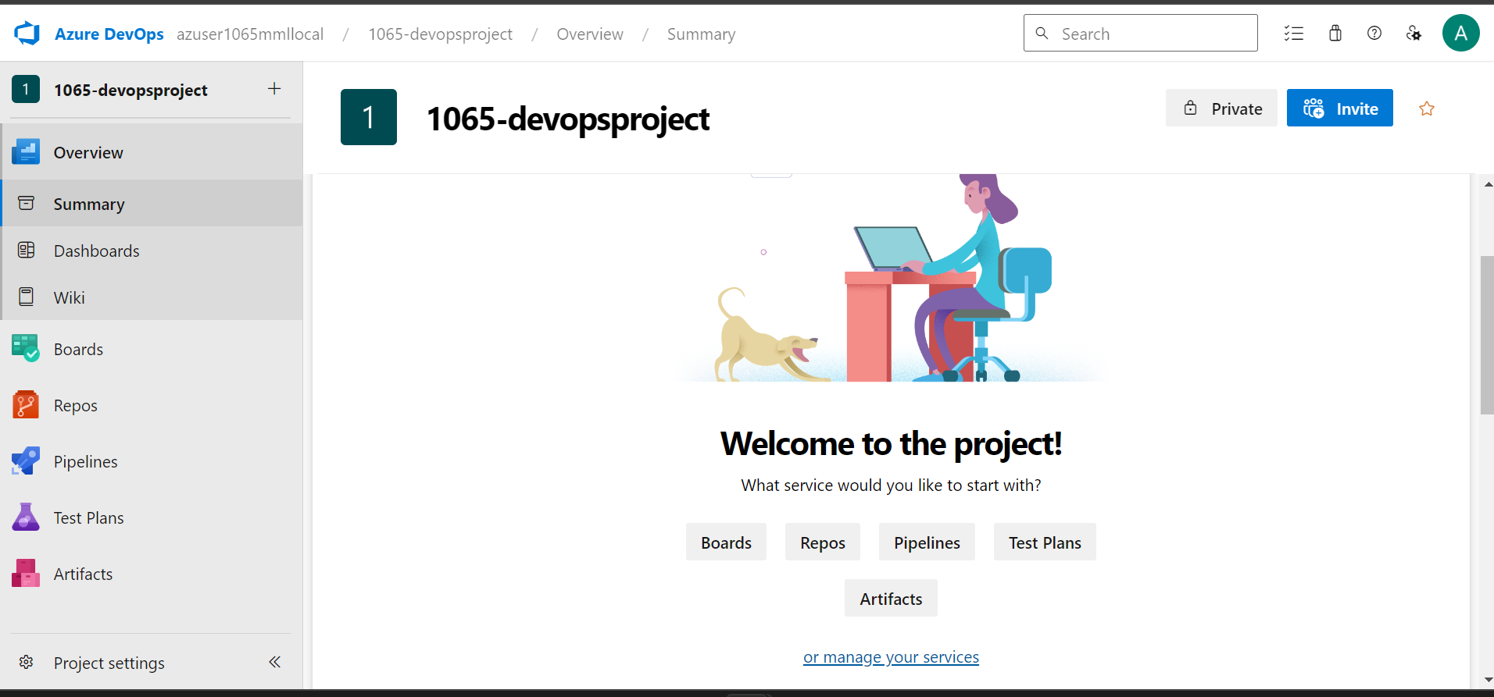

1. Create a Repo

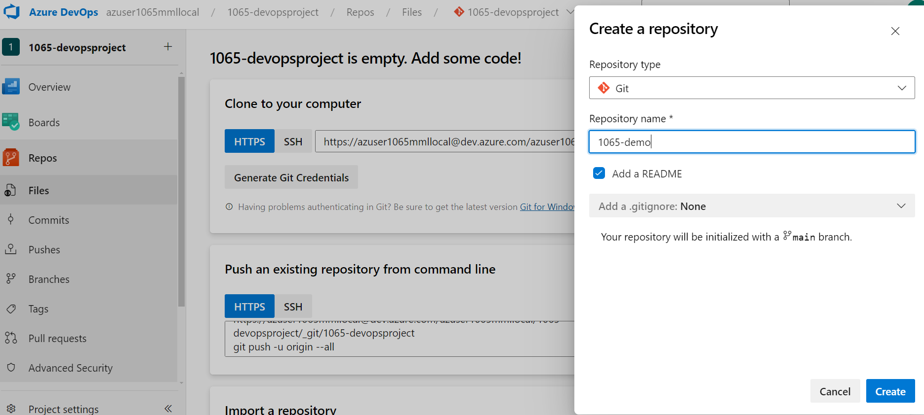

1. Now Select Clone.

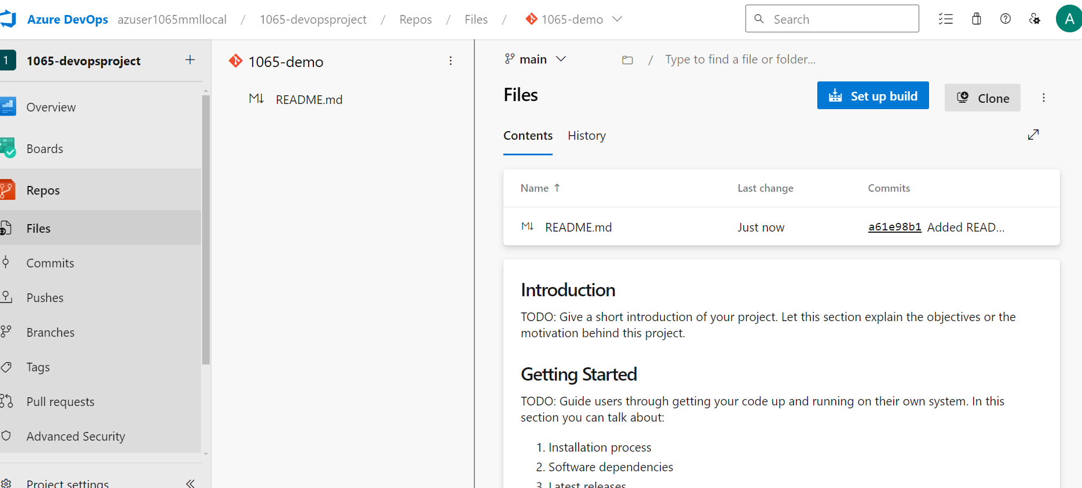

1. Successfully Clone the repo.

